

**Product Dissection for facebook**

### **Company Overview:**

**Facebook** is a social media and social networking service owned by American

technology Meta platforms.It was created in 2004 by Mark Zukerberg with four others.They completed their graduation from Harvard College.Facebook can be accessed from devices with internet connectivity, such as personalcomputers, tablets and smartphones.After registering, users can create a profile revealing information about themselves.Facebook has attracted millions of users worldwide, making it one of the leading platforms in the social networking landscape.

### **Product Dissection and Real-World Problems Solved by Facebook:**

The problem that Facebook has gone on to solve is one of making the world more open and enabling more & stronger connections to emerge between people. Relationships are fundamental to society and Facebook has developed tools to help more people connect to each other and share whatever they want.A personalized feed displaying updates from friends, pages, and groups.Users can share status updates, photos, and more on their profiles.Users can connect with others and organize them into friend lists.Facebook provides a powerful advertising platform with targeted ad delivery based on user demographics, interests, and behaviors.It gives the facilitates online social networking, helping users stay connected with friends, family, and acquaintances.It allows users to share a variety of content, from personal thoughts to major life events, with their network.Facebook has privacy settings that allow users to control who sees their content and implements security measures such as account verification and login alerts.

In conclusion, Facebook’s product design has successfully tackled real-world problems by creating a platform that nurtures creativity, fosters connections, and offers a space for self-expression. Through its diverse features, Facebook addresses the need for authentic engagement, content curation, and meaningful discovery, shaping the digital landscape and providing practical solutions to the evolving needs of its global user base.

### **Case Study: Real-World Problems and Facebook’s Innovative Solutions**

Facebook is a leading social media platform, has not only revolutionized the way we share and consume content but has also addressed significant real-world challenges through its innovative features. By identifying user needs and leveraging technology, It has positioned itself as a solution-driven platform that fosters connections, encourages self-expression, and enhances digital interactions.

In a fast-paced world, individuals face challenges in staying connected with their social circles, sharing information efficiently, and maintaining meaningful interactions. The abundance of information also makes it difficult to curate relevant content and engage in a personalized manner.

**1-Personal Profiles and Timelines:**

* **Problem:** Challenges in sharing personal updates and life events.
* **Innovative Solution:** Facebook's core feature allows users to share status updates, photos, and life events on their profiles and timelines. This creates a personalized space for individuals to express themselves and share their stories with friends and family.

**2-News Feed Algorithm:**

* **Problem:** Information overload and difficulty in curating relevant content.
* **Innovative Solution:** Facebook introduced a sophisticated News Feed algorithm that prioritizes content based on user interactions, interests, and behaviors. This ensures that users see the most relevant and engaging content in their feeds, addressing the challenge of information overload.

**3-Friendship and Networking:**

* **Problem:** Difficulty in maintaining connections in a dynamic and global environment.
* **Innovative Solution:** Facebook facilitates online social networking by allowing users to connect with friends, family, and acquaintances. The friend request and acceptance mechanism, along with friend lists, provide users with tools to organize and manage their social connections.

**4-Groups and Pages for Community Building:**

* **Problem:** Difficulty in creating and sustaining communities.
* **Innovative Solution:** Facebook's Groups and Pages feature allows users to create and join communities based on shared interests, causes, or affiliations. This fosters community building and engagement, providing a space for like-minded individuals to connect.

**5-Messenger for Real-Time Communication:**

* **Problem:** Need for efficient and real-time communication.
* **Innovative Solution:** Facebook introduced Messenger as a standalone messaging app, enabling users to engage in private conversations, share multimedia content, and create group chats. This innovation enhances real-time communication within the Facebook ecosystem.

**6-Events Feature:**

* **Problem:** Challenges in organizing and inviting people to events.
* **Innovative Solution:** Facebook's Events feature simplifies event planning, invitations, and RSVPs. Users can create, discover, and participate in events, addressing the need for efficient event coordination.

### **Top Features of Facebook:**

Facebook offers a range of features that cater to various aspects of social networking, communication, and content sharing. Please note that features and functionalities may have evolved since then. Here are some of the top features of Facebook:

**1-News Feed:**

* The central feed where users see updates, posts, and content from friends, groups, and pages they follow.

**2-Friends and Connections:**

* Users can connect with others by sending friend requests, accept requests from others, and organize connections into friend lists.

**3-Messenger:**

* A standalone messaging app for private conversations, group chats, and multimedia sharing.

**4-Likes, Reactions, and Comments:**

* Users can express their sentiments towards posts through likes, reactions (such as love, haha, wow, sad, angry), and comments.

**5- Privacy Settings:**

* Users can customize the visibility of their content, control who can see their posts, and manage friend lists to control access to their profile.

**6-Tagging and Mentions:**

* Users can tag others in posts, photos, and comments, as well as mention them to get their attention.

**7-Video Sharing:**

* Users can upload and share videos on their profiles, pages, and in groups.

**8-Notifications:**

* Users receive alerts about activities, comments, friend requests, and events through notifications.

**9-Live Video:**

* Users can broadcast live videos to their followers and engage in real-time with their audience.

**10-Suggested Friends:**

* Facebook suggests potential connections based on mutual friends, interests, and other factors.

### **Schema Description:**

The schema for Facebook involves multiple entities that represent different aspects of the platform. These entities include Users, Posts, Comments, Likes, Followers, Hashtags, and more. Each entity has specific attributes that describe its properties and relationships with other entities.

**User Entity:**

Users are at the core of facebook. The user entity contains information about each user:

* **UserID (Primary Key)**: A unique identifier for each user.
* **Username**: The chosen username for the user's account.
* **Email**: The user's email address for account-related communication.
* **Full_Name**: The user's full name as displayed on their profile.
* **Bio**: A brief description that users can use to express themselves.
* **Registration_Date**: The date when the user joined Instagram.

**Post Entity:**

Posts capture the visual content shared on the platform:

* **PostID (Primary Key):** A unique identifier for each post.
* **UserID (Foreign Key referencing User Entity**): The user who created the post.
* **Caption**: Text accompanying the post, providing context.
* **Image_URL**: The URL of the image or video content.
* **Location**: The tagged location associated with the post.
* **Post_Date**: The date when the post was created.

**Comment Entity:**

Comments enable users to engage in conversations around posts:

* **CommentID (Primary Key)**: A unique identifier for each comment.
* **PostID (Foreign Key referencing Post Entity):** The post being commented on.
* **UserID (Foreign Key referencing User Entity)**: The user who posted the comment.
* **Text**: The text of the comment.
* **Comment_Date**: The date when the comment was posted.

**Like Entity:**

Likes represent user appreciation for posts:

* **LikeID (Primary Key):** A unique identifier for each like.
* **PostID (Foreign Key referencing Post Entity):** The post being liked.
* **UserID (Foreign Key referencing User Entity):** The user who liked the post.
* **Like_Date:** The date when the like was registered.

**Hashtag Entity:**

Hashtags categorize and group content:

* **HashtagID (Primary Key):** A unique identifier for each hashtag.
* **Tag**: The actual text of the hashtag.

### **Relationships:**

* **User-Post (One-to-Many):**
  + A user can create multiple posts, but each post is created by one user.
* **User-Comment** **(One-to-Many):**
  + A user can write multiple comments, but each comment is for one user.
* **User-Like** **(Many-to-Many):**
  + A user can like multiple posts, and each post can be liked by multiple users.
* **Post-Comment (One-to-Many):**
  + A post can have multiple comments, but each comment is for one post.
* **Post-Like (Many-to-Many):**
  + A post can be liked by multiple users, and each user can like multiple posts.
* **Comment-Like (Many-to-Many):**
  + A comment can be liked by multiple users, and each user can like multiple comments.
* **User-Friendship (Many-to-Many):**
  + Users can be friends with multiple other users.

**ER Diagram:**

Creating a comprehensive Entity-Relationship (ER) diagram involves visualizing the entities, attributes, and relationships in a clear and concise manner. Below is a simplified representation of the ER diagram for a social media platform like Facebook based on the schema described earlier:

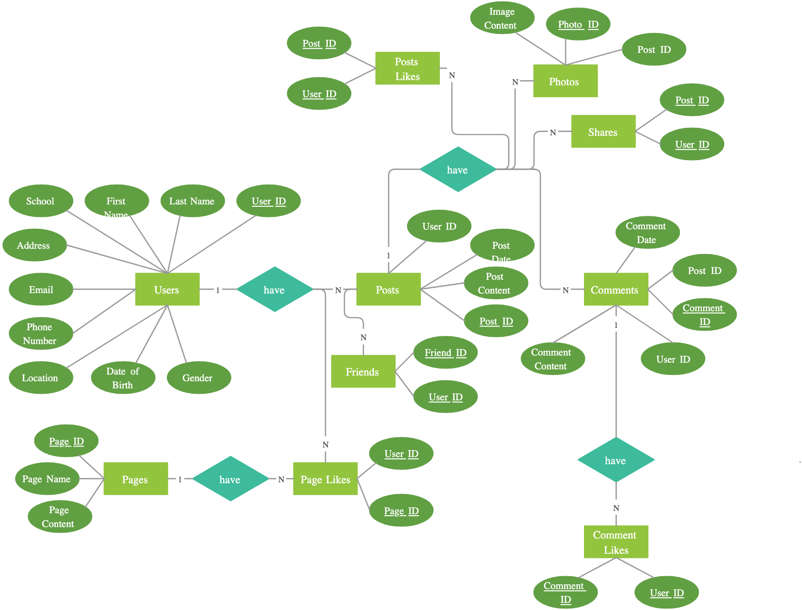

### **Conclusion**

In conclusion, creating a database schema for Facebook involves a thoughtful design that addresses the platform's features and functionalities. The provided Entity-Relationship (ER) diagrams offer a simplified representation of the key entities and relationships within the Facebook ecosystem.

The user-centric design places Users at the core, connecting them to various entities such as Posts, Comments, Likes, and Friendships. Relationships are established to capture the interactions and associations between these entities, providing a foundation for the diverse functionalities offered by Facebook.